

**MS804 Systems Development & Project Management**

**EFFECTIVE PROJECT MANAGEMENT APPROACH FOR START-UPS USING SCRUM**

|  |  |
| --- | --- |
| **Student Name *(Group No - 16)*** | **Student ID** |
| SAYALI SHILAMKAR | 19230056 |
| JAYAKARTHI BOOVENDRAN | 19230487 |
| DEVANSHI THAKKAR | 19230665 |
| KARAN MUDALIAR | 19230845 |
| MUTHU SELVI MANIKAVASAKAM | 19230063 |

***PAPERS REVIEWED:***

1. Startup Critical Analysis and Reasons for Failures, IkboljonKasimov, 2017.

2. Startups Roads to Failure, Marco Cantamessa, 2018.

3. Startup Framework based on Scrum Framework, Sirin Thongsukh, 2017.

4. Project Management using the Scrum Agile Method: A case study within a small enterprise, Breno R. L; Alan D. S, 2015.

***WORD COUNT*: 5064** *(Main body – excluding references and table of content)*

***DATE OF SUBMISSION:*** **30/10/2019**

**TABLE OF CONTENTS**

**Abstract** ……………………………………………………………………………………3

**Introduction** ……………………………………………………………….........................4

**A Detailed Inspection of the Root Causes of Failure**……………………………………6

**Root Causes of failure**…………………………………………………………………….11

**Agile – The Proposed Solution**…………………………………………………………...12

**Implementing Agile in Startups**……………………………………………………….....17

**Conclusion**………………………………………………………………………………....22

**References**…………………………………………………………………………………25

**ABSTRACT**

The primary objective of the study is to provide an efficient project management solution for start-ups, on their way to becoming a developed enterprise. As per statistical reports, over 90% of the start-ups fail due to numerous reasons and the lack of efficient project management technique is the crucial factor that causes the failure.  Therefore, the central focus of this study is to address the issues on the lack of proper project management. Furthermore, the paper takes into account the peculiarities of start-ups, the root causes and barriers that create the failure and a suitable project management solution is proposed to approach those issues. Moreover, the proposed solution is backed-up by established results from four of the case studies. To maintain a degree of accuracy, proper research is executed to guarantee the compatibility of the proposed solution to the start-ups. Furthermore, a detailed description of achieving SCRUM in start-ups is also included in the study.

In general, the key characteristics of start-ups are time-critical deadlines and limited resources. Start-ups frequently fail due to their inability to accommodate to the changing requirements, lack of team management and inefficiency to deliver on time. All the above-mentioned issues can be rectified through SCRUM. Some of the prominent qualities of SCRUM like the sprint planning, daily scrum meetings, sprint review and validation of backlogs help to tackle the concerns with the start-ups. The study also covers the benefits of implementing SCRUM in start-ups.

**INTRODUCTION**

In typical, a startup consists of four major phases which includes Startup, Transition, Scaling and Exit. Startup is the most essential phase where the idea, business model and project management framework come into picture. This is the phase that determines the entire life cycle of the startup, including definition of business idea till end-to-end validation.

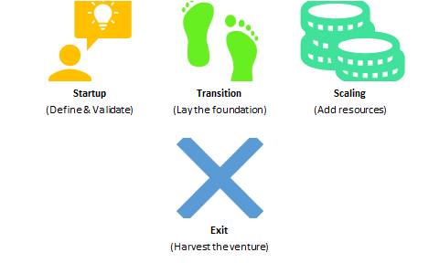

In the Transition phase, the startup enters into the target market and lays its roots. In case of the Scaling Phase, entrepreneurs add required resources for business growth. Finally, in the exit phase the actual turn-over is obtained from the venture. This is the deciding factor that determines the growth of the startup. (Picken, 2017)

The startup landscape has changed drastically over the past decade which demands for the entrepreneurs to come up with creative ideas and viable project management technique which serves no guarantee for success and no direct solution.

**Relationship between Business Model and Business Strategy**

Business Model is an overall structure which depicts the operation of company, funds and its goals. Business strategy is a part of business model which defines the goals and business strategies. (Pahwa,2019)  
 

**Difference between Startups & established companies**

The lion of entrepreneurship Mr. Howard Stevenson, a professor at Harvard Business School Sarofim-Rock, claimed that startups are different from administrative organization in six ways and those critical factors give them an edge over new-born startups in the wars of attrition. According to him “Startups pursue opportunities with resources that don’t match the task; although they may have one or two critical ones such as product idea or access to an experimental customer, they lack all resources required to win”. (Kasimov, 2017, p 2)

His six ways of difference between startups and administrative companies include:

* Strategic Orientation
* Style of Resource Commitment
* Decision-Making Approach
* Attitude towards Asset Accumulation
* Management Structure and Style
* Approach to Rewards

**Traditional Startup Vs Emerging Startups:**

A traditional startup relies on the notion of constructing a business setup that is generated from a combination of elaborate coming up with and intuition. In ancient startups execution is against a disciplined business originated that's usually static in nature. So, it is not adaptive to the new desires or issues.

On the other hand, rising Startup is not related to discipline business and is usually dynamic – instead, its mission is to search out a productive business model. Famous Businessman Eric Ries, also the author of the famous book ''The Lean Start-up", has a distinct approach to reasons of startup failures. He emphasized that new ventures build products that that no-one needs to shop for, despite however amazing the technology might be. It's the largest waste of time, talent and resources in a startup. (Kasimov, 2017, p 1)

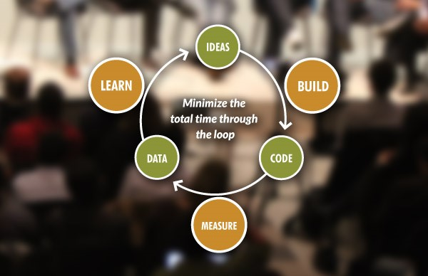

“The Lean Startup method teaches a way to manage a startup-how to drive and grow a business with maximum acceleration.” (Theleanstartup.com. 2019).

**A DETAILED INSPECTION OF THE ROOT CAUSES OF FAILURE**

By the time you were reading this report 40 or more start-ups are created. 137,000 businesses come to life every day and 50 million in a year. But 90% do not see the light of the day, they fail...In plain mathematics 123,300 fail every day, and by the time you were reading up to here, approximately 85 businesses were already shut down. This statistic won’t inspire you to start up a new venture. But with proper analysis of the factors contributing to failures and with proper management and appropriate measures you can be one step ahead than the rest of the crowd.

Start-ups are difficult to sustain in this technology driven world where user requirements keep on changing every day.

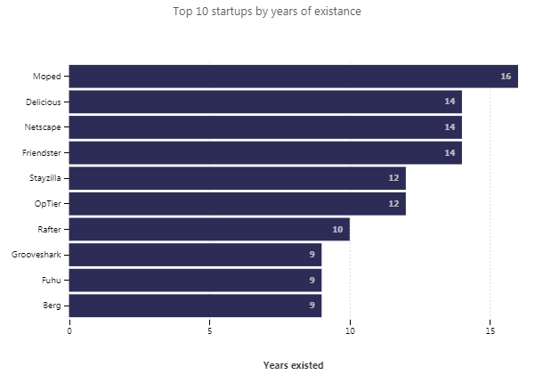

Let us roll into the factors that contribute to start-up failure but before that lets consider the motive to start a new business. Start-ups are born with many intentions and each of them contributes on deciding a successful business. Global Stats say that around 84% of entrepreneurs create a business by choice instead of necessity: -

* **Recognition:**

More than 75% of the start-up ideas are put into force just to gain money and overnight fame.

* **Empowerment and Authority:**

From deciding the start-up name to team building to logistics everything needs to be done by the entrepreneur himself. Rather than working under the normal hierarchical structure of any company the entrepreneur here has the whole authority to start and end it and be sole responsible for his actions.

* **Unemployment:**

4.5% of the start-ups are started just because it is difficult to get a tradition employment.

* **Job satisfaction:**

Majority of the entrepreneurs does not find their corporate job challenging enough. They wish to get that extra credit they long for.

* **New Idea / Innovation:**

An Idea is all you need to put an entire team into force.

* **Work Environment:**

Working in a start-up also provides you with work flexibilities unlike any corporate company which has many confidential and client restrictions. So, it is difficult to get the life work balance.

But is your startup idea innovative enough to survive this completive world? Your one step can make or break the business. Are you up for that authority? Who will be your target customers? Do you have enough fund to raise an entire organization? Are you ready to take risk? Do you have enough skilled resources?

Many factors lead to the failure of a New Venture. Let us dig into the statistics of the major management root causes of startup failure for the last 15 years.

**OTHER FACTORS AND MYTHS THAT DO NOT LEAD TO STARTUP FAILURE:**

The other major external factors or myths that accounts to the root causes of a startup failures are as follows: -

* **Age:** Mark Zuckerberg was 19 years of age when he founded Facebook. Colonel Sanders founded KFC at 60 years of age. So, age is just a number. The average age of successful entrepreneur is 45 years.
* **Gender:** Women led start-ups are not that successful compare to males is a myth. Companies with a women founder performed 63% better than companies with entire male crew.
* **Global Recognition:** Starbucks took 16years to expand outside of Seattle. Jeff Bezos never doubted Amazon even when its stock fell to $6. You do not get overnight success, fame and money you need. Consistent and perseverance is the key for a successful start-up.
* **Need Team:** Over a third of US Businesses have fewer than 100 employees. Business with fewer than five employees makes up to 62% of all businesses in the US.
* **Marital Status:** 70% of the successful entrepreneurs are already married during opening of their first business.

**Industry Failure Statistics: -**

Below is the analysis of 214 startups extracted from Autopsy.io website and of the CB Insights. According to the analysis majority of the startups failed in the Social Median domain accounting to 12.3% of the failure rate. Forget start-ups, well establish companies like Google had to shut down its Google Buzz, Google Wave, Google Plus social networks. Each of them where released where released in 2009, 2010, 2011 respectively every year in order to rival Facebook but any of those did not sustain as the former Google products did not had anything new to offer to its users. Facebook on the other hand has been dominating the social media industry for the past 10+ years. Facebook always has something new to offer to it users which hooks the users. On the other hand, Instagram is now dominating the Facebook since the former contains more visual images than content which eases the customers. So, in order to sustain one must have a deeper insight of the ever-changing customer needs and market trends. The Software industry accounts to 9.3% failure rate followed by Service industry which is 8%.

The Startups in Ed-Tech arenas accounts to 0.50% failure rate. The most commonly used Ed-Tech – Blackboard [Revenue: $694.5M] established in 1997 which previously started its year with small school clients. As of January 2014, its software and services are used by approximately 17,000 schools and organizations in 100 countries with over 24 million users. This accounts to almost 80% of worlds academic institutes. Canvas [Revenue: $39.8M] is perceived as one of Blackboard's biggest rivals. Canvas generates only 5.73% of Blackboard's revenue. Blackboard's revenue is always high than its competitors. Hence, proper management of resources in whatso ever industry sector is utmost important at least in the initial stages of a startup. Also, the Hardware, Security and Telecommunication industry on the other hand account to failure rate of 0.5%. This is because not many startups target these arenas because the capital required to build a startup in telecommunication and hardware industrial sectors is more compare to that of the social media and software industry. The raw materials required the manufacturing and establishing unit, the geographical conditions etc. all these factors are considered while proposing a new business plan in these areas of industry. Hence this requires a proper insight of the business plan and funds. The amount of money invested in these industrial startups is directly proportion to all risk factors one considers while starting a new business.

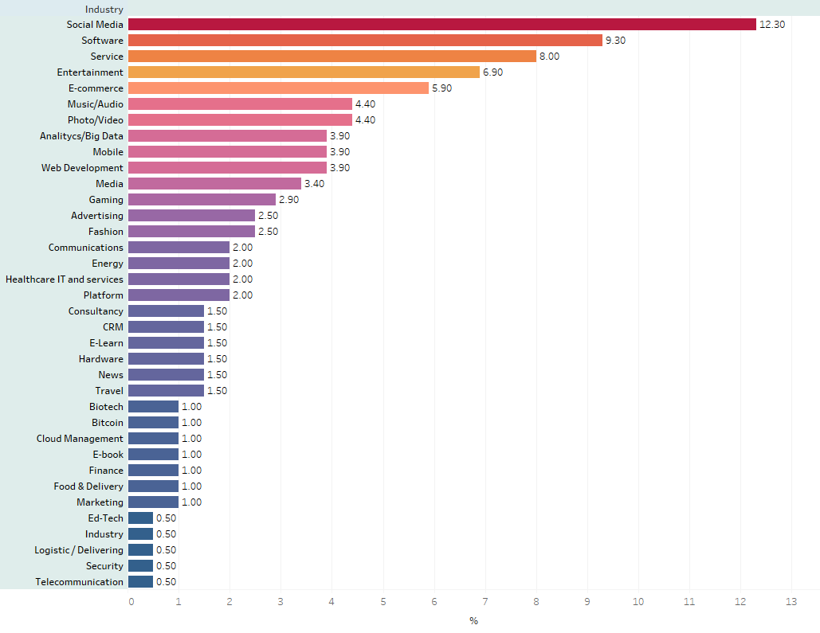

*Fig:* Sustainability*(ISSN 2071-1050; CODEN: SUSTDE). Page No. 9 (https://www.mdpi.com/2071-1050/10/7/2346/pdf)*

There are ample of other external factors too that lead to the success or failure of a startup. So, in the next section we have taken into consideration some aspects for building a successful business model which can be implemented at any stage of the startup development lifecycle. This might not eliminate the risk of failure but to some extent it might help to set the business focus and meet the requirements of a successful venture.

**ROOT CAUSES OF FAILURE**

BEEPI [Worth $149M]- Failed. Reason: Bad Leadership, high Salaries and High Expenses.

JUICERO [Worth $118.5M]- Failed. Reason: Not acknowledging feedback and being too expensive.

Pepper Tap [Worth $51.2M]- Failed. Reason: Ran out of Funding.

A startup can fail at any point of the startup development lifecycle. It can fail at the early initial phases or even after surviving 10 years in the market. One bad decision, one competitor or one trend change in market is more than enough to blow up the night long efforts. So, in order to survive the changing winds in technology it is necessary to understand the major factors influencing startup failures.

**The main reasons behind failure can be outlined as follows:**

1. According to L.Rising and N.S.Janoff et al., as the current requirements of software development often changes the development teams are facing problem and they cannot easily cope up with the changing requirements.

2. Quality of the process and quality of the product are closely related. Quality of the process impacts the quality of the product. Moreover, the quality of the product directly depends on its development process. And many start-ups fail to achieve a good development process.

3. Start-up business failing to develop good organized process and tracking process in return fails to develop a good product.

4. A survey outlines the main cause of failure as the in-appropriate planning of work implementation.

5. Many times failure arises because of the unclear goals to be achieved and any kind of miss-communication between the colleagues.

Moreover, most of start-ups do not follow any methodologies for planning.

6. One of the most important factors that tend to start-up failure is the lack of team management and an unimproved work process in start-ups.

**(“Thongsukh”, “Ayuthaya”, “Kiattisin”, 2017, (I) Introduction)**

**Therefore, this theory will help to propose an agile developing software methodology called SCRUM as a solution for the same.**

**AGILE – THE PROPOSED SOLUTION**

Which is the Project Management framework that is best suited for small enterprises like startups? Is Agile only for grown enterprises? When does a startup should adopt to agile? A few questions rose while brainstorming to find the optimal project management solution for the chosen problem. Moreover, several case-studies backed-up the solution that we opted, with proof enough to justify the fact that implementing agile is the best way to achieve exponential growth and sustainable profit in smaller organizations just like the startups. Based on which, is our proposed solution. To confirm the compatibility of agile project management methodology with start-ups, a close analysis of both agile and start-ups is performed and is enclosed below.

According to statistical records, over 90% of the start-ups fail due to several reasons. Out of which, the absence of effective project management is one of the essential factors that cause the failure. One of the studies of Harvard Business School proposes that 3 out of 4 start-ups fail due to lack of project management (Deborah Gage, 2012). Another research confirms that nearly 50% of start-ups fail within five years and 70% fail within 10 years of starting (Statistic Brain, 2017)

*Figure: Characteristics of a typical startup*

**Startups – A Closer Picture**

In a typical start-up, the team is usually small with almost 5-10 people and time is the most valuable asset. In general, the timeline for planning and execution in a startup is very small. Besides, the team also needs to take in constant feedback, re-iterate on the ideas, and make better decisions based on the new information and provide rapid delivery in spite of the shorter timeframe. Plus, the requirements gathered are in general unstable, which results in a clumsy SDLC. Furthermore, the efforts put must be sustainable as the budget and resources are limited. (Breno R. L; Alan D. S, 2015)

*Figure: Start-up’s Focus on Delivery*

A good startup is one which allows for rapid decision making, streamlined workflow, and agreement on how things should be done. Furthermore, the adopted project management technique should allow for steady execution and consistent functioning of the enterprise. Startups are supposed to be extremely dynamic as they react quickly to market changes, new technologies and competitive products. Thus, the preferred project management system must allow and support for before-mentioned alterations. Besides, the project management process must be convenient to accommodate if the business scales. One of the most powerful ways of making things fall in place is through Agile.

**Agile - An Overview**

Agile is a set of defined principles and practices implemented throughout the entire project life cycle. Underneath this project management system, the solutions evolve through collaboration and co-operation of the team. The agile implementation helps in planning, development, and timely delivery of products and services. Moreover, it helps in increasing team performance for faster and sustained growth. Some of the most popular agile project management methodologies include Scrum, Extreme Programming (XP), Dynamic Systems Development Method (DSDM), Feature-Driven Development (FDD), and Lean Development. Agile is an extensive collaborative project management framework, which enables tackling a project at different stages that involve a steadfast collaboration with continuous iteration and refinement. To be precise, Agile focuses on addressing time-critical projects with rapidly changing requirements through the implementation of defined principles and disciplined methods.

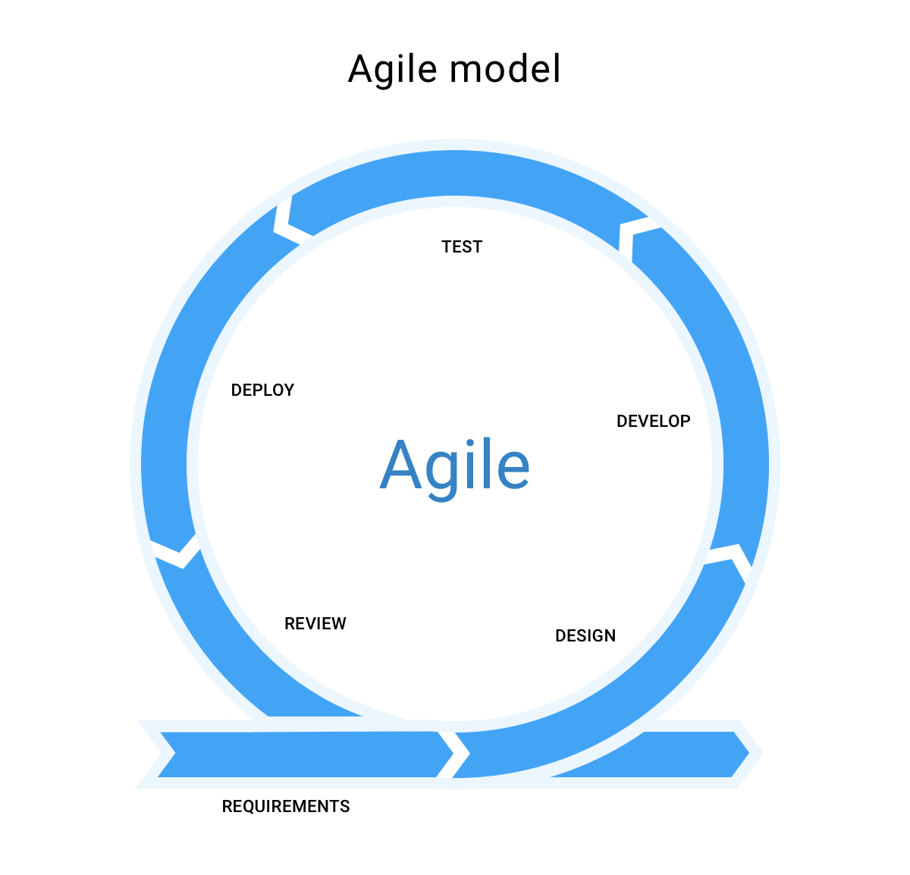

*Figure: Agile SDLC Model (*[*https://www.learntek.org*](https://www.learntek.org/)*)*

**Advantages of Agile**

Following are some of the major advantages of agile [1],

* Ability to adapt to rapidly changing requirement
* Faster delivery of working product when compared to a conventional project management model
* Ability to accommodate Customer feedback at every stage of the deliverable and re-iterate with the new product information
* Enables better Team management, time-boxing and efficient communication through continuous inputs from the clients and target customers throughout the project life cycle
* Decreases the time demanded to acquire some of the system options and benefits.
* Allows testing during the design cycle
* Implementation of agile practices is flexible and has fewer risks
* Incorporating modifications, alterations and refinements to the system take comparatively less time
* Allows producing predictable, high-quality product deliverable in the least possible timeline with maximum customer satisfaction.

**Agile VS Start-up**

It requires careful strides to achieve project completion in a startup. In general, the size of the projects is small and quick delivery is demanded. On the other hand, Agile typically operate on small teams that focus on quick deliverables. Every sprint, a portion of the product deliverable is released. Moreover, enhancements are done continuously by receiving customer feedback.

|  |  |
| --- | --- |
| **Startup** | **Agile** |
| * Small Project * Smaller Teams (5-10 people) * Shorter Deadlines * Must provide quick delivery * Should accommodate Customer feedback and requirement changes * Requires continuous improvement | Agile typically works with small teams focusing on quick deliverables. Pieces of the project are released continuously over time. The project is then refined by receiving customer feedback and is re-iterated to accommodate the new requirements. |

Agile has the advantage to move fast and deliberately make decisions that quickly adjust to the position of the organization, which makes it widely compatible with startups. The Agile process is systematic, and the results are predictable. In the Agile's hands-off approach to development, every problem is broken down into bits. Each developer in specific is assigned a scope of work that they must deliver within a precise timeline. Furthermore, it allows us to take quicker decisions, implement in short time and merge short feedback loops. The crucial component is that the employees and managers must be given adequate training on implementing the Agile. Furthermore, employees need to grasp the importance of agile in real-time.

**Advantages of Agile in Startups**

Some of the key characteristics of Agile methodology that favors startups to deliver:

* Agile allows for timely and constant deliverables leading to greater customer satisfaction.
* Provides an advantage of controlling continuous changes from the customer
* Brings together the team throughout the project and paves the way to avoid double-dealing of efforts.
* Focusing on a shorter timescale.
* Offers transparency and precision while communicating within the development teams or remote teams through dedicated and cheap agile software
* Promotes continuous development at a constant pace

Summing up, Agile is especially suited for environments with unknown factors and ambiguity. Besides, the key principles are a short feedback loop, inspecting and adapting to the changing requirements. All the above-mentioned factors make agile the best-suited project management technique for start-ups. In the sections to come a complete picture of implementing Scrum in start-ups is incorporated.

**IMPLEMENTING AGILE (SCRUM) IN START-UPS**

**As we got an idea about the solution proposed in this theory and the reason for it, further we will proceed with the implementation part of the solution. The below theory will help us to know how Scrum can be implemented in start-ups and how it will be helpful.**

**Defining AGILE (SCRUM):**

**“Scrum is one of the agile development methodologies”. (“Thongsukh”, “Ayuthaya”, “Kiattisin”, 2017, (I) Introduction)**

**Scrum can be defined as a collaborative method to achieve the expected goals. An agile framework that can be applied to the processing way of the team rather the direct product or the output. SCRUM can help to reduce the complex product development process by managing the process followed by the team.**

**Implementation of AGILE (SCRUM)**

**1. Various Roles played in Scrum:**

Three important roles are involved in Scrum namely Product Owner, Scrum Master, and Development team. The below diagram and the explanation will give an idea about different roles that are played in Agile**.**

ROLES IN AGILE

Development team

*Product Owner*

*Scrum Master*

*Fig: Different roles played in SCRUM (“Thongsukh”, “Ayuthaya”, “Kiattisin”, “Startup Framework based on Scrum Framework”, 2017, 1(I))*

1. **Product Owner**: Product Owner plays a vital role in the Scrum framework. They create and prioritize the work and the tasks.

2. **Scrum Master**: Can be titled as the controller of the team who takes a follow up of the progress made by the team and looks into whether the team is progressing successively towards the expected goal or not. Also is responsible to take up the daily scrum meetings and sprint planning (will be discussed in the future).

3. **Development Team:** It can be termed as the team members of the whole team including everyone who works to achieve the desired goal. The development team includes developers, testers, Business Analysts and other stakeholders.

One of the best ways the scrum team follows is the self-organization without having any dependency on external teams or factor.

**2. The SCRUM Methodology**

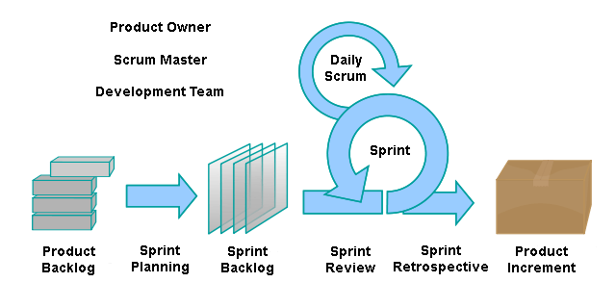

*Fig: The SCRUM flow [6]*

The above figure gives us an idea about how the development process can be completed using the SCRUM framework going through different phases.

The scrum framework flow is followed by the sprint planning meeting.

**1. Sprint:** The small iterations in scrums are known as sprint. It is about 2 weeks to 4 weeks long. The actual development of the product takes place during these weeks.

**Outcome:** Helps the team members to get an overview of the whole work to be done in the next few days and the time for the same before starting with the work.

**2. Sprint Planning Meeting**: Before starting each sprint, the sprint planning meeting is held which involves the whole team. It is generally used to plan the work to be done within the sprints. The items in the sprint backlog (explained further) are presented by the product owner to the team stating the priority for each item. Generally, if two weeks of a sprint are followed then the sprint planning meeting lasts for 4 hours.

**Outcome: It** provides an opportunity for each team member to participate in the requirements gathering, analysis and maintains transparency within the team.

**2. Product Backlog**: It is the list of the pending tasks that need to be done in coming sprints order on the basis of value, risk, priority, and necessity. Items are added to the product backlog by the product owner along with the estimated time required to complete it on discussion with the team members. The product owner is the authorized person to add, delete or revise the items if business conditions change. All team members have access to the product backlog which helps them to view the backlogs and track the sprint work. Different tools can be used to list the product backlog and manage for all teams for e.g. JIRA. “Jira is a family of products built to help all types of teams manage their work. Jira offers several products and deployment options that are purpose-built for Software, IT, Business, Ops teams, and more.” [5]

**Outcome:**As all team members haveaccess to product backlog helps them to track the work going in the team. Moreover, this provides transparency.

**3. Sprint Backlog:** This includes the set of items selected for the sprint from the product backlog list. Teams are free to select the items to be included in the sprint.

**Outcome**: This helps in giving a visual outline of the sprint and work to the team members.

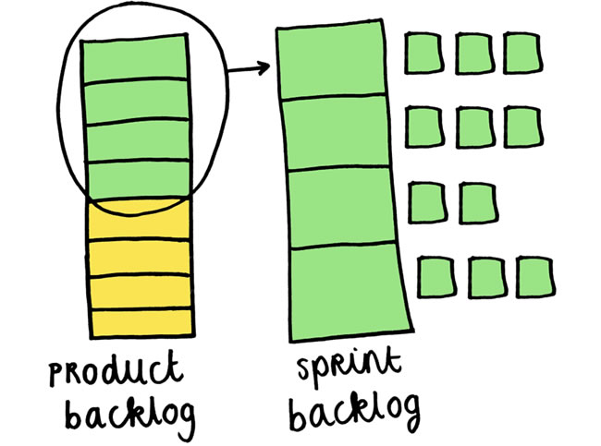

*Fig: Depicts the overview of product backlog and the sprint backlog (*[*https://reqtest.com/category/agile-blog/page/5/*](https://reqtest.com/category/agile-blog/page/5/)*)*

**4. Daily Scrum Meetings:** A 15-minute long daily meeting is undertaken by the team in order to individually discuss the questions like “What was done since the last scrum meeting?”, “Were there any Obstacles?” and “What will be the next step?”.

**Outcome:** This expects each team member to answer to these questions and discuss them with the whole team. If any obstacles are noticed, then they can be discussed within the team and resolved at an early stage.

**5. Weekly SCRUM-OF-SCRUMS:** This meeting is undertaken once in a week lasting for 30 minutes. It is generally between different teams to know the status of each team.

**Outcome:** This helps in the distribution of the information between the teams and reveals possible problems early on.

**6. Sprint Review:** After the sprint is over a demo is undertaken for the work done which is called a Sprint review. The team represents the work completed in front of all the members including the stakeholders which are also called a sprint demo. The stakeholders and the scrum team then work together to discuss the acceptance of the work done and any changes if required. It takes place for 2 hours for a two-week sprint. It also inspects the increment and adapts the product backlog.

**Outcome:** It helps team members to represent their work in front of stakeholders making it more interactive for the business. Changes, if any can be suggested by the stakeholders there itself, are the added to the sprint backlog and a priority is set accordingly.

**5. Sprint Retrospective:** Sprint retrospective is implemented after the sprint review. It basically aims at giving feedback for the work done and future improvements. In order to do these three main topics are discussed by the team namely: “Good points during the last sprint”, “Bad points during the last sprint” and “Area of improvements”. Each team member is expected to give their opinion on these topics. It generally lasts for 3 hours. It gives a chance to the teams to inspect their past work and create a plan for the next sprint.

**CONCLUSION**

In this study we took on a problem “Why Startups are failing?” and did a detailed analysis of the root causes which caused the failure and proposed a solution that helps overcoming the problem. In majority of the cases where the startups failed, it is either due to the selection of a business model that is not best suited for the problem or it is due to the lack of proper project management framework. Out of which, we have focused on the issues relating to the project management in a start-up and have proposed a project management framework that is optimal for the startups to have an exponential growth and sustained profit. Furthermore, the proposed solution is adaptable even when the startup scales to a grown enterprise.

Any enterprise should have a project management technique that is compatible with the features and peculiarities of the organization. Since startups are dynamic in nature, the proposed project management technique must be able to accommodate the dynamic and ambiguous nature of startups. To add-up, the startups should be futuristic in nature and be able to sustain the ever-changing market trends and requirements. One of the renowned project management frameworks that has the exact features to that of a typical startup is the Agile methodology. In specific, we have dealt with Scrum framework in this study. More contribution to the study helped us analyze the solution for this problem as “Agile methodology (Scrum)”. This solution mainly focuses on changing the existing methods followed by the team to a new agile method called SCRUM.

“Process quality and product quality are closely related, and process improvements benefits arise because of the quality of the product depends on its development process. Scrum framework can be applied in team process of tech start-ups. Scrum can help the process of tech start-up to save time and money and the team gets clear visibility through scrum meetings. Also works well for fast-moving development projects.”(“Thongsukh”, “Ayuthaya”, “Kiattisin”, 2017,5(E)).

From a survey created to test whether Tech Start-ups based on scrum framework were satisfied by the results, few points were considered, and questions were asked accordingly to the Tech start-ups. The results revealed that 10 Tech start-ups company were successful in Thailand using scrum framework. Moreover, 70% of participants were unaware of the scrum framework and about 58% faced problems with the process of working. But overall, 95% of the participants were satisfied with the Scrum framework which solved the problems in process with the team member and supplied to process of working to be efficient. (“Thongsukh”, “Darakorn”, “Ayuthaya”, “Kiattisin”, 2017,5(E)).

More study was done with the Scrum methodology in start-ups referring a small case study as follows.

**Case study:**

The following reference of case study gives us an idea about the benefits the following companies had after practicing the SCRUM methodology. This case study basically deals with the distributed projects. It is stated that “Even though all case projects faced challenges when taking scrum into use, the overall experience was very positive”( .(“**Paasivaara”,”Durasiewicz”,”Lassenius”,2009 ,p201** ).Although these companies had a distributed projects they managed well to follow scrum.

**“Energy Resource”** had a distributed project with multiple teams at different locations. It was challenging for them to communicate for daily scrum meetings for which they used Telephone conferencing and web-cameras as the solution.

“**Print-co”** on the other hand had only one project but was distributed. They managed the daily scrum meetings using IRC**. Both the companies in the case study faced few challenges but were happy with the Scrum framework which increased their success rate.**

The below table will give the names of the companies which were interviewed and the benefits they had after using SCRUM.

|  |  |
| --- | --- |
| **COMPANY NAME** | **RESULTS/BENFITS** |
| 1. **Printco:** Service Company. Development of a new version of printing service software for internal use in new markets. (“**Paasivaara”,”Durasiewicz”,”Lassenius”, 2009 ,p201** ) | 1.”Transperancy to a project, especially in distributed projects. .”Reveals possible problems early on.”  3. “Creates contacts and encourages to informal communication especially between the sites”.  4. “Provides frequent monitoring opportunities”.  5.”Gives an opportunity for every team member to participate, ask questions and communicate within the team.  6. “Ensures the understanding of requirements to all the team members.”  7. “All team members can access, pick items and follow the progress”. (“**Paasivaara”,”Durasiewicz”,”Lassenius”,2009,p201)** |
| 1. **Printco:** Service Company. Development of a new version of printing service software for internal use in new markets. (“**Paasivaara”,”Durasiewicz”,”Lassenius”, 2009 ,p201** ) |

**REFERENCES**

**References:**

1. “Start-up Framework Based on Scum Framework”, ”Sirin Thongsukh”, “Smitti Darakorn Na Ayuthaya”, “Supaporn Kiattisin”,2017.

2.” Using Scrum in Distributed Agile Development: A multiple case study “,” Maria Paasivaara”,”Sandra Durasiewicz”,”Casper Lassenius”.

3. “From startup to scalable enterprise: Laying the foundation. Business Horizons”, Picken, J. (2017), 60(5), pp.587-595.

4. “Critical Analysis of Startups and Reasons for Failure”, Kasimov, Ikboljon. (2017).

5. Pahwa, A. (2019). Business Strategy: Definition, Levels, Components & Examples | Feedough. [online] Feedough. Available at: <https://www.feedough.com/business-strategy-definition-levels-examples/> [Accessed 29 Oct. 2019].

6. Theleanstartup.com. (2019). The Lean Startup | Methodology. [online] Available at: <http://theleanstartup.com/principles> [Accessed 29 Oct. 2019].

7. “Startups’ Roads to Failure. Sustainability”, Cantamessa, M., Gatteschi, V., Perboli, G. and Rosano, M. (2018), 10(7), p.2346.

8. [1] Available online at**:** <https://www.learntek.org/blog/sdlc-models-software-development-life-cycle-models/>

9. [2] Deborah Gage, 2012; Available Online at: <https://www.wsj.com/articles/SB10000872396390443720204578004980476429190>

10. [3] Statistic Brain, 2017; Available Online at: <https://www.statisticbrain.com/startup-failure-by-industry/>

11. [4] “Project Management using the Scrum Agile Method: A case study within a small enterprise”, Breno R. L; Alan D. S, 2015; 12th International Conference on Information Technology, IEEE.

12. [5] (<https://www.atlassian.com/software/jira/guides/getting-started/overview>).

13. [6] *(*<https://kanbanzone.com/2017/scrumban-blending-agile-scrum-kanban/>)